PuTTY Key generation and Configuration
Jemmy Hu, Feb. 2013

1. Key Generation

1.1) Open PUTTYGEN, select the Type of key to generate, then click ‘Generate’
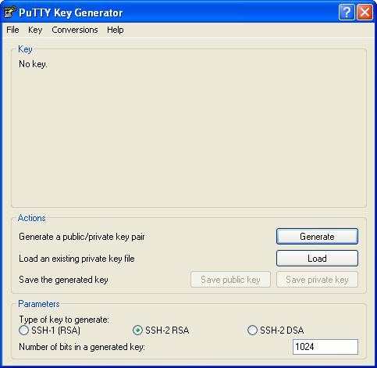

1.2) Keys are generated, click ‘Save public key’ and ‘Save private key’ separately, name and save the keys on your PC.

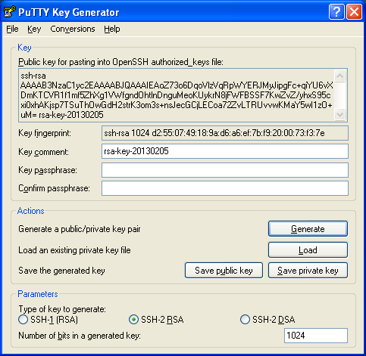

I saved them as matlab_dce in C:\Program Files\Putty, the private key name is matlab_dce.ppk

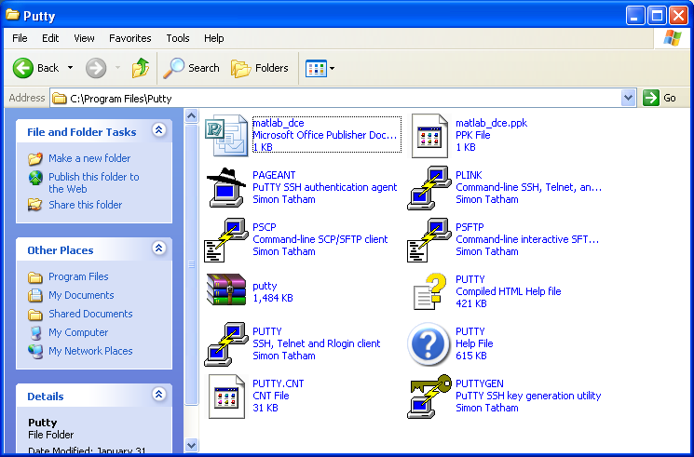

1.3) Convert the private key to OpenSSH key. Click Conversions in the PUTTYGEN window, import the private key, and Export to OpenSSH key

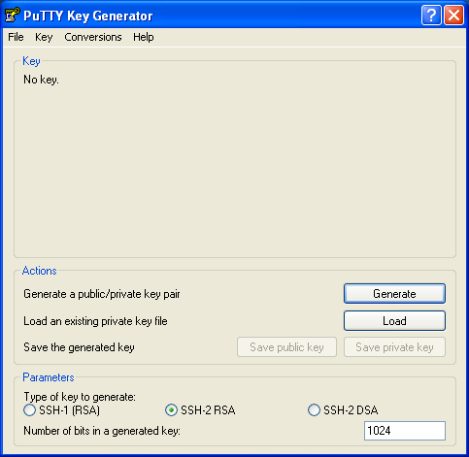

1.4) Name and save the OpenSSH key as ‘id_rsa’

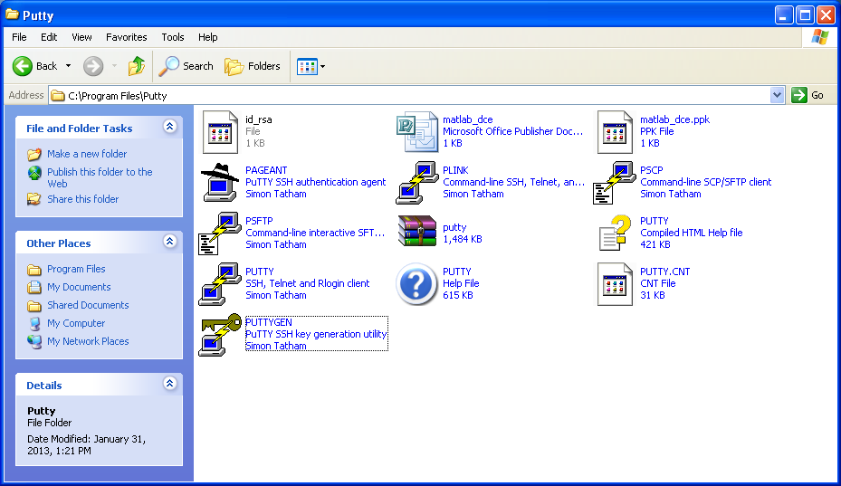

1.5) Copy the public key to the remote cluster such as orca, add it to ~/.ssh/authorized_keys.
My file look like

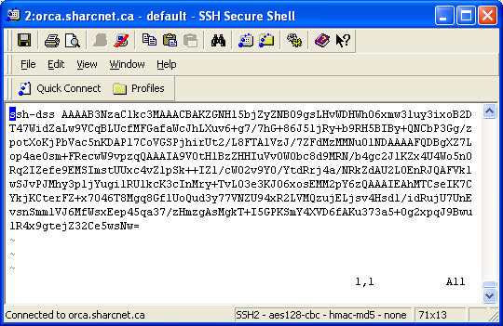

Logout and login again, the key setting should be fine now.

2 PuTTY Client Configuration

2.1) Open a PuTTY window. Click Connection -> SSH ->Auth, Browser the OpenSSH key, i.e.,

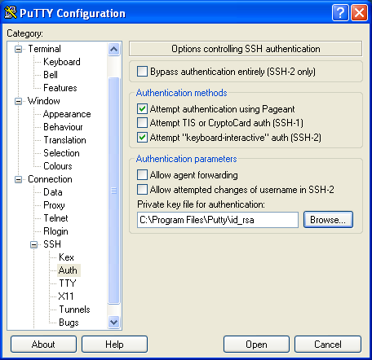

  - click Connection -> Data, enter the Auto-login username (your SHARCNET username)

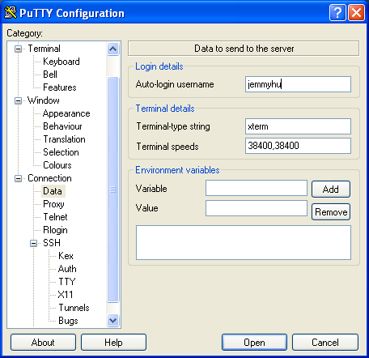

  - from Session, type the cluster Host Name, type it also in the ‘Save Sessions’ and click ‘save’ button

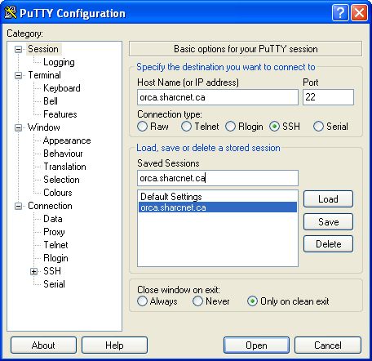

2.4) click ‘Open’ button, if succeeded, the auto-login window will look like
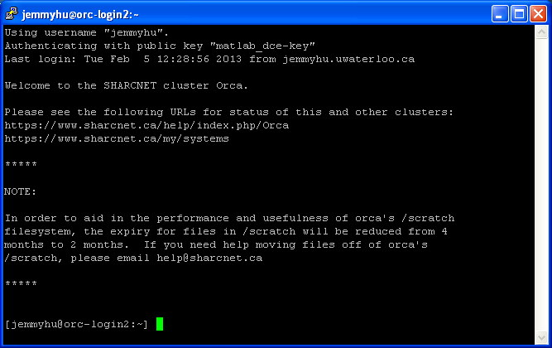

You should be OK now, Cheers!

